**Ant’s Tour**

There is N rods on a line. A rod can be represented by an interval [p-r, p+r] with a central point p and a distance r. An ant on a rod S1 can move into the other rod S2, when S1 and S2 intersect (Note they also intersect when their intervals meet at the end points). That is, S1∩S2≠∅.

All rods have an identical distance r. An ant starts from a rod A, moves through rods, and arrives at a rod B. Also the ant starts from the rod B, moves through the other rods different from the rods which it visited previously, and arrives at the rod A. Then the set of rods which it visits is called a tour between A and B. If P is the tour between A and B, then the ant visits A twice and it visits all the other rods just once. Of course, the tour between A and A is the singleton set containing only itself. For example, in the Figure 1, the movement of an ant A → C → E → D → B → A is a tour between A and E. Also it is a tour not only between A and C but also between A and D, and it is also a tour between A and B.

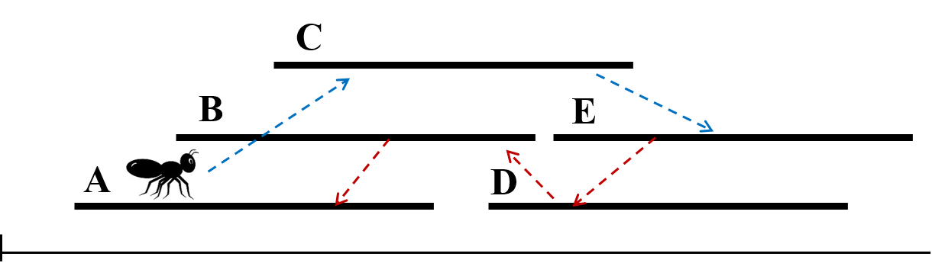

Figure 1.

We shall change the nonnegative integer value r, that is, the length of a rod (In case r = 0, a rod is represented by a point). In particular, we shall change r so that there can be a tour between A and B for all the pairs of rods A and B. In this case, find the minimum of r.

[입력]

The number of cases T is given the first line of the input file. Here, T ≤ 60. In the first line of each case, the number of rods N(2 ≤ N ≤ 100,000) is given. In each of the following N lines, an integer p is given representing the central point of a rod (1 ≤ p ≤ 1,000,000,000).

The input is given from the following three sets.

* Set 1: 2 ≤ N ≤ 100.
* Set 2: 2 ≤ N ≤ 10,000.
* Set 3: 2 ≤ N ≤ 100,000.

[출력]

Print the minimum of r such that there can be a tour between A and B for all the pairs of rods A and B.

[I/O Example]  
Input

|  |
| --- |
| 2  6  7  6  12  1  14  3  8  20  12  7  3  32  25  15  29 |

Output

|  |
| --- |
| 4  5 |